**Arnab Samanta**

We trained VAE for 30 epochs and ran inference on random 20 images encoding their respective latent space to a 16 dim vector and sampled Zs from its distribution. We then created a random tensor(६)of size 16 and an OHE tensor of the same dimension with 1 being present randomly at one the index. We then multiplied this OHE with ६ and added to the latent vector. This changed the latent vector allowing us to see the changes on the final output image based on the dimension changed. Here is an illustration of the same.

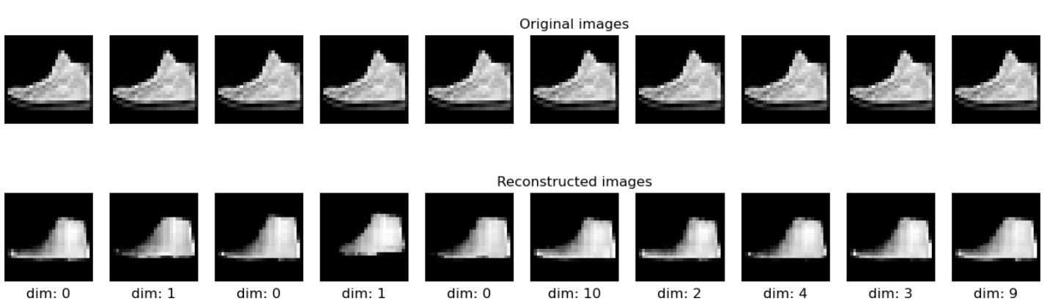

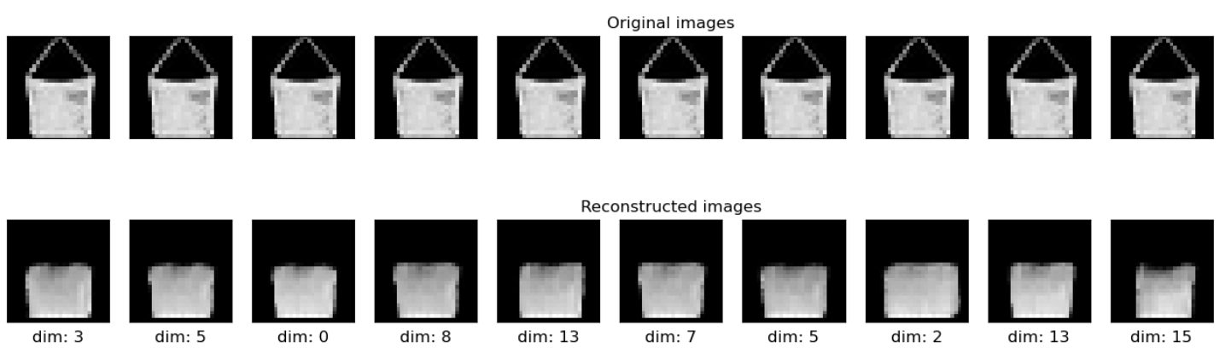

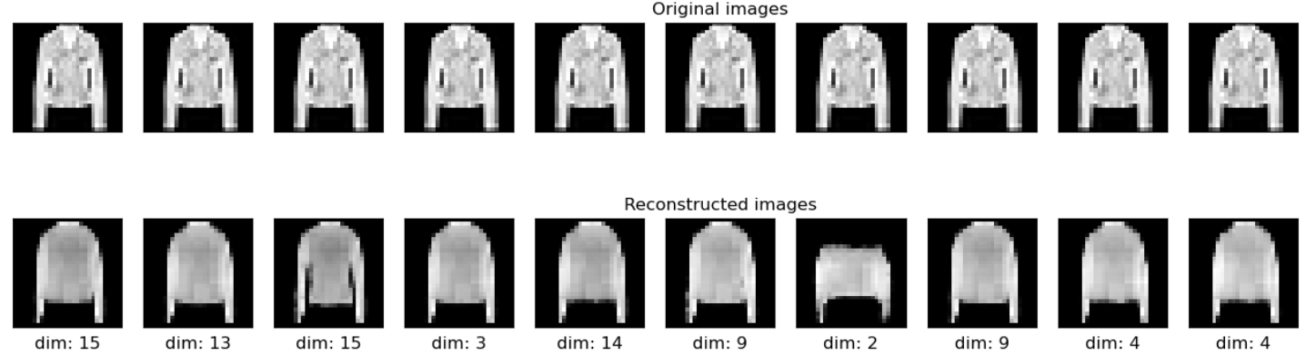

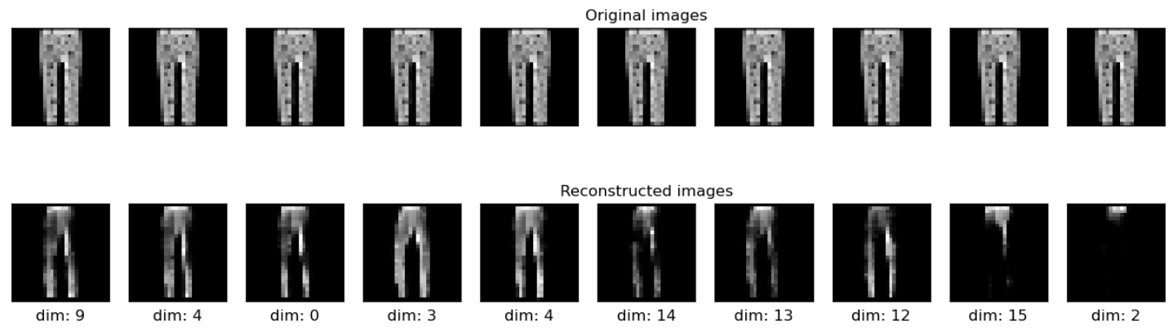

To estimate the ability to learn for the Variational Autoencoder, we can also generate new images by drawing latent vectors from the random normal distribution.

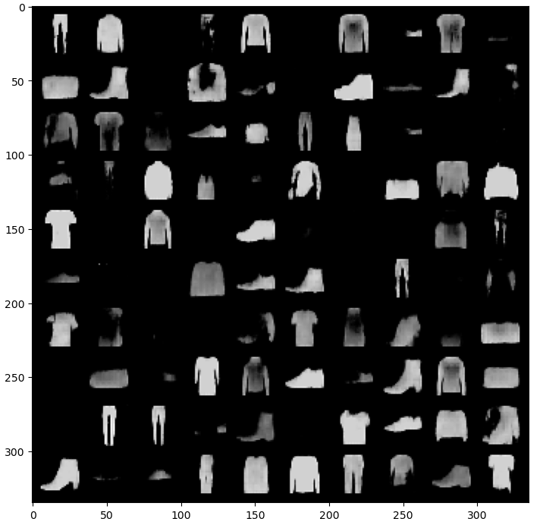

Majority of the generated samples look like fashion items, so the Variational Autoencoder seems to have learned robust patterns from the latent space.